**II. WHY AGILE**

Introduction

Lesson Introduction

Welcome to the lesson on why Agile has taken the market by storm in today's digital age.

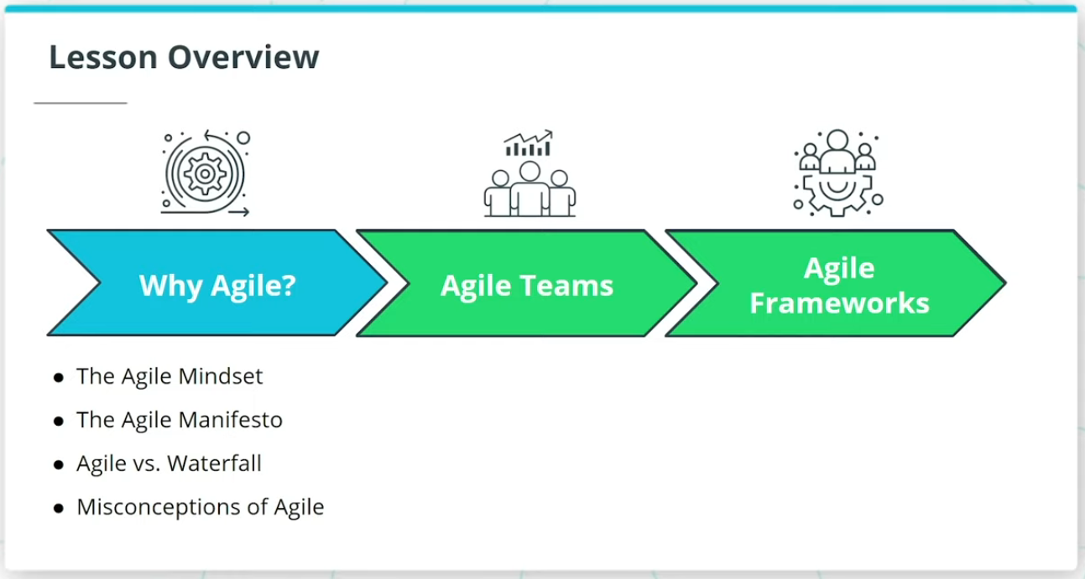

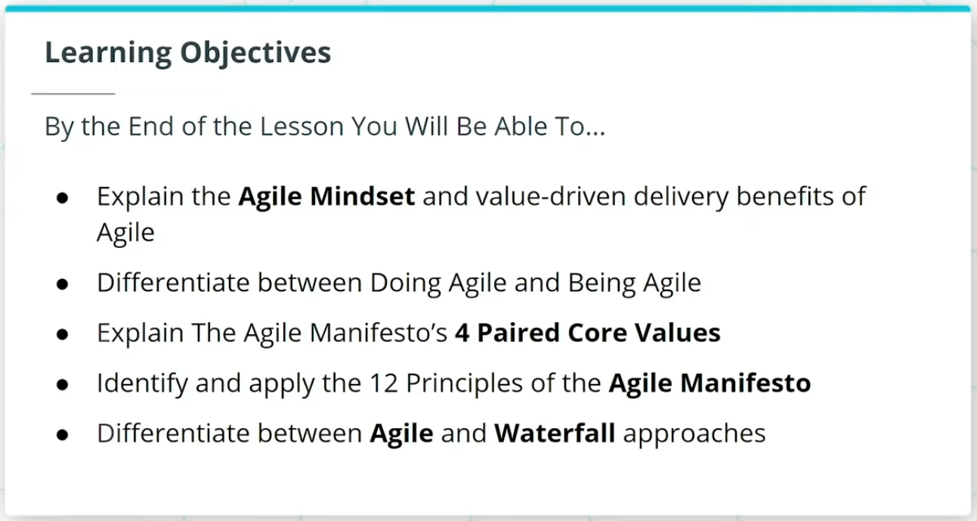

### **What We Will Cover In This Lesson**

In this lesson, we will focus on the foundational theory behind Agile. We will discuss:

* The Agile Mindset and how it sets the tone for ‘Being’ Agile versus just ‘Doing’ Agile
* The Agile Manifesto, and how it is seen as the foundational set of 4 Paired Core Values and 12 Principles that sets the foundation for all Agile Frameworks
* How Agile differs from the more traditional Waterfall approach to product development

We will wrap up the lesson with an important discussion on common misconceptions about Agile.

### **By the End of the Lesson, You Will Be Able To...**

* Explain the Agile Mindset and value-driven delivery benefits of Agile
* Differentiate between Doing Agile and Being Agile
* Explain The Agile Manifesto’s 4 Paired Core Values
* Identify and apply the 12 Principles of the Agile Manifesto
* Differentiate between Agile and Waterfall approaches

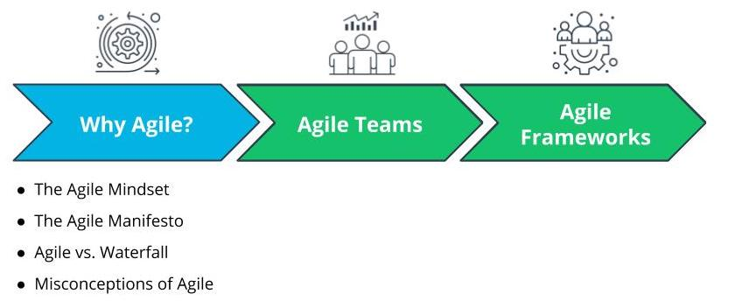

What We Will Cover In This Lesson

# Why Agile

## Why Are Organizations Adopting Agile Part 1

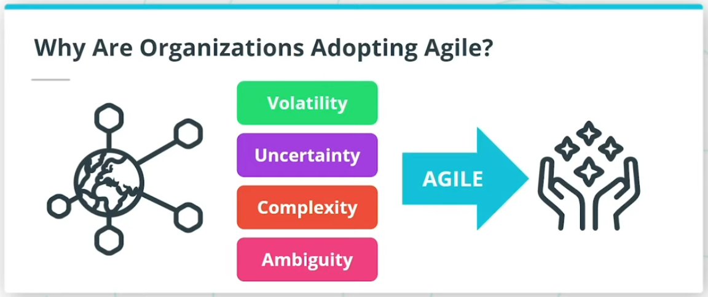

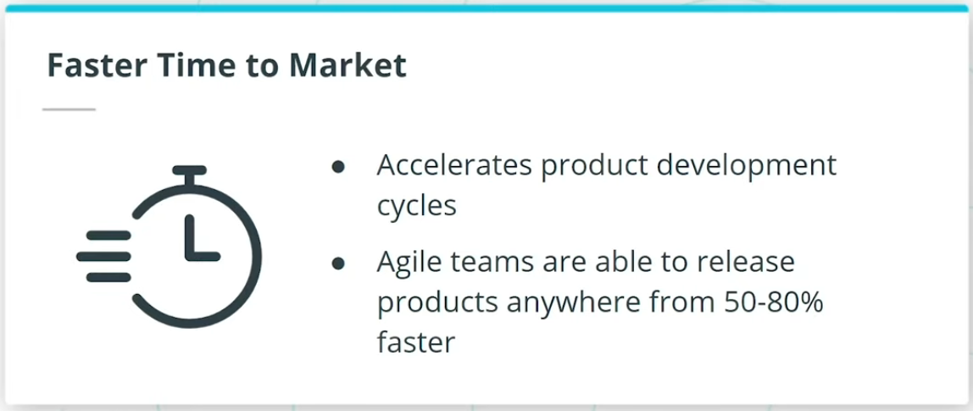

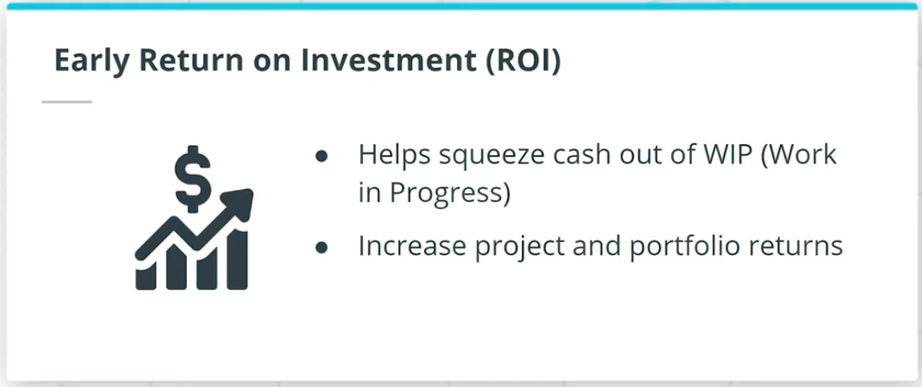

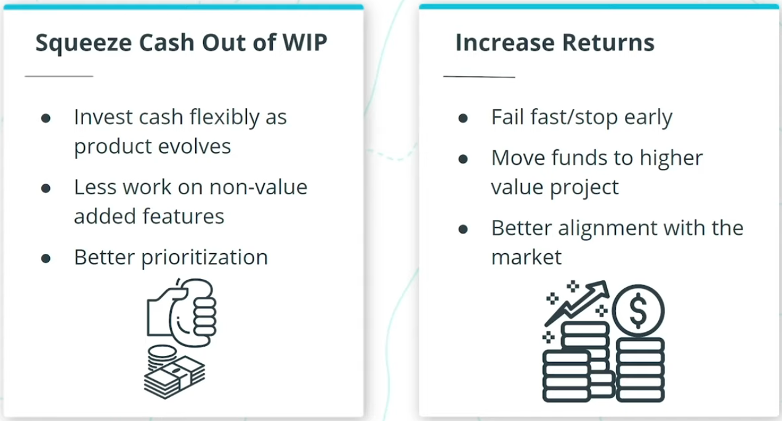

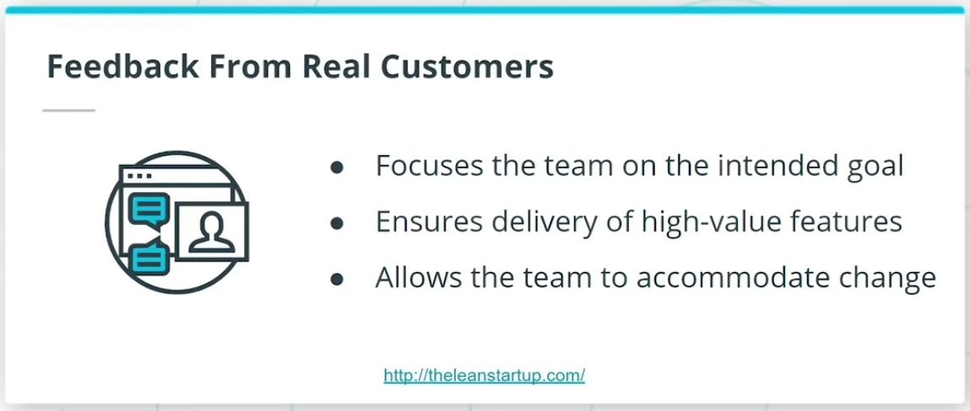

So, why are forward-thinking organizations rapidly adopting Agile? And why are we seeing that global professional bodies such as The Project Management Institute (PMI) in their PMBOK Guide and The International Institute of Business Analysis (IIBA)’s BABOK Guide, have incorporated and highlighted the importance of Agile in project management, business analysis, and other product delivery activities?

In an increasingly interconnected and competitive global marketplace, I am seeing Agile being leveraged by successful organizations across the globe to thrive in today’s digital age. Agile enables organizations to predictably deliver value in a world where we are constantly being challenged with Volatility, Uncertainty, Complexity, and Ambiguity. Organizations that I have seen go through Agile transformation have benefited from the following:

* Faster time to market
* Early ROI
* Feedback from Real Customers

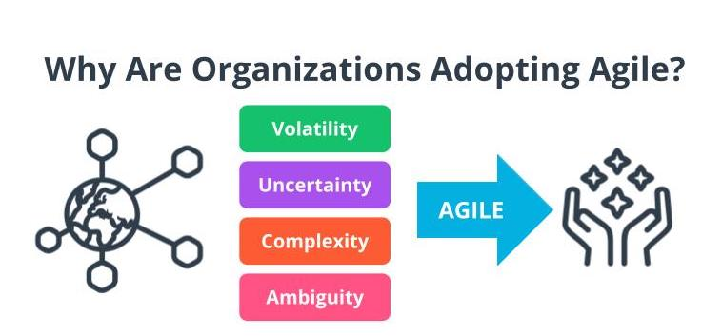

Volatility, Uncertainty, Complexity, Ambiguity

*Note: You are going to learn more about VUCA later in this lesson.*

Why Are Organizations Adopting Agile Part 2

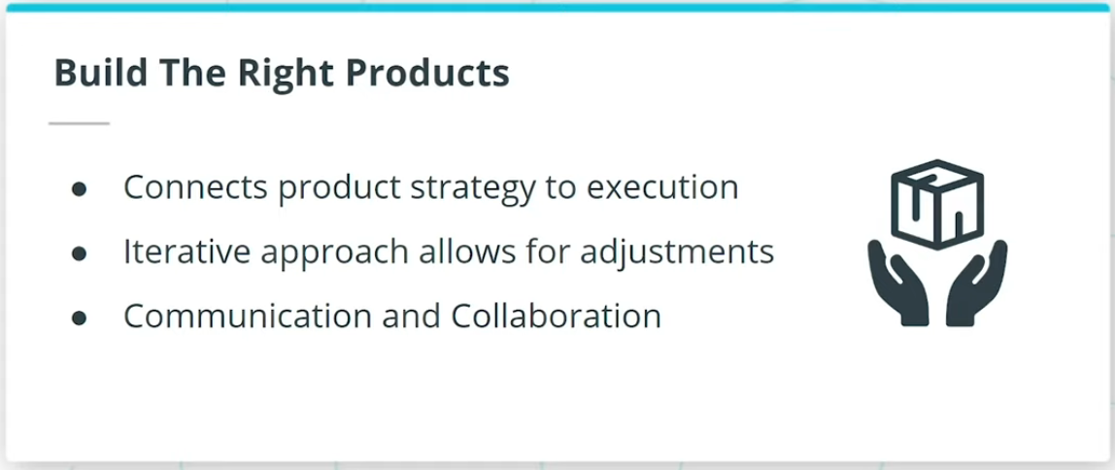

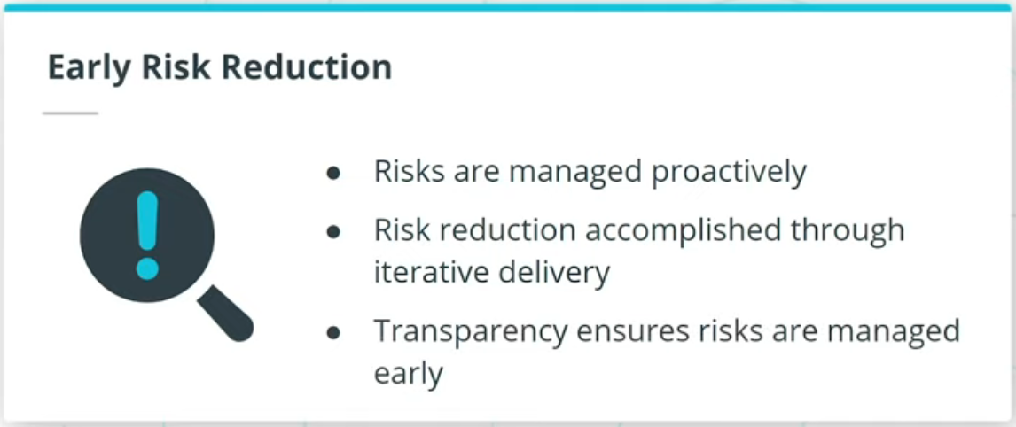

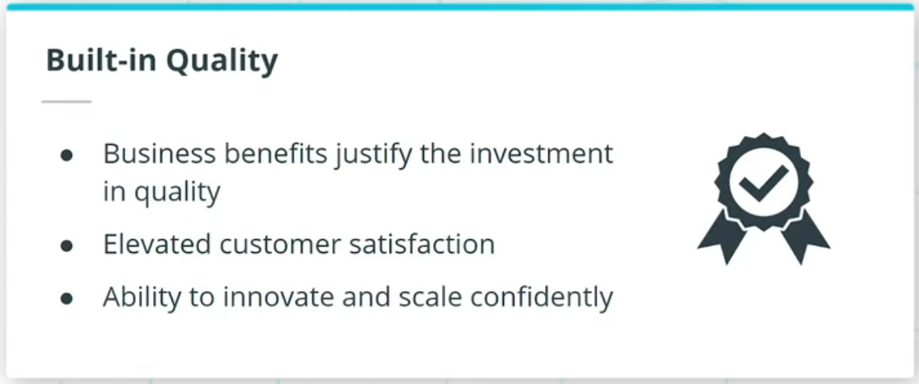

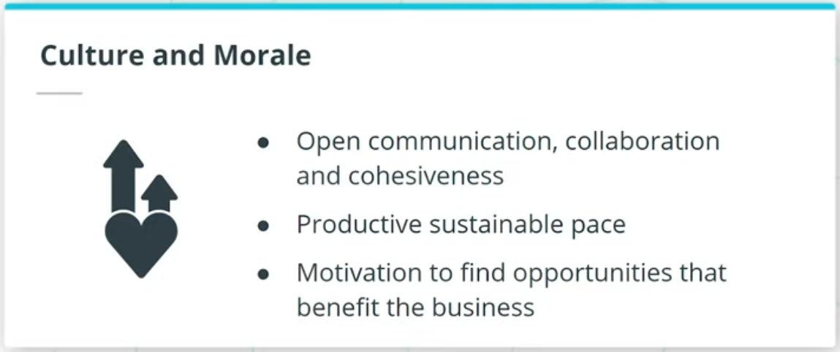

### **Organizations that go through Agile transformation have also benefited from:**

* Build the right products
* Early risk reduction
* Built-in quality
* Culture and morale

## Efficiency vs. Effectiveness

